Portable pro-formance at your fingertips

[Watch Video](https://www.kingston.com/en/video/play?videoId=ZJ-H8TmkPVRhyF0LGlewa-YrDwOAQVkau3tRSIRGCxnyGxyScwbEnJGFTdtGQMLCqRagg8CF7C_JKzUwDmEEbw2&start=0&autoPlay=False&chromeless=False&captionOption=No)

XS2000

* [Intro](https://www.kingston.com/en/ssd/xs2000-portable-usb-c-solid-state-drive#product-features)
* [Key Features](https://www.kingston.com/en/ssd/xs2000-portable-usb-c-solid-state-drive#key-feature)
* [Specifications](https://www.kingston.com/en/ssd/xs2000-portable-usb-c-solid-state-drive#specifications)
* [Resources](https://www.kingston.com/en/ssd/xs2000-portable-usb-c-solid-state-drive#links)
* [Datasheet](https://www.kingston.com/datasheets/XS2000_us.pdf)

[**Buy**](https://www.kingston.com/en/ssd/xs2000-portable-usb-c-solid-state-drive#atc)

XS2000 External Solid State Drive (SSD)USB Type-C 3.2 Gen 2x2 Portable Drive

Kingston’s XS2000 Portable SSD utilizes USB 3.2 Gen 2x2 speeds to deliver next-gen performance in a compact, external drive. With lightning-fast transfer speeds up to 2,000MB/s1, XS2000 delivers enhanced productivity with little interruption. XS2000 offers high-speed storage options to offload and edit high-res images, 8K videos, and large documents in a flash. With up to 4TB2 of portable capacity, you can store your favorite games and media without compromise. The drive is future-proofed to keep up with storage demands and compatible with most devices out of the box. It functions just like a hard drive but stores data using NAND flash technology. It connects with USB Type-C®3 allowing content creators and gamers to access their data anywhere. Whether you go between work, play and passion projects, the XS2000 includes a removable ruggedized sleeve for drop protection up to 6ft and IP55-rating4 to withstand water and dust, making it the perfect companion for on-location photoshoots or adventures.

* Speeds up to 2,000MB/s1 with USB 3.2 Gen 2x2
* Capacities up to 4TB2
* Compact, pocket-sized form factor
* IP55 rating4 with removable rubber sleeve

Key Features



Pocket-sized Portability

Small, lightweight form factor for easy, on-the-go storage.

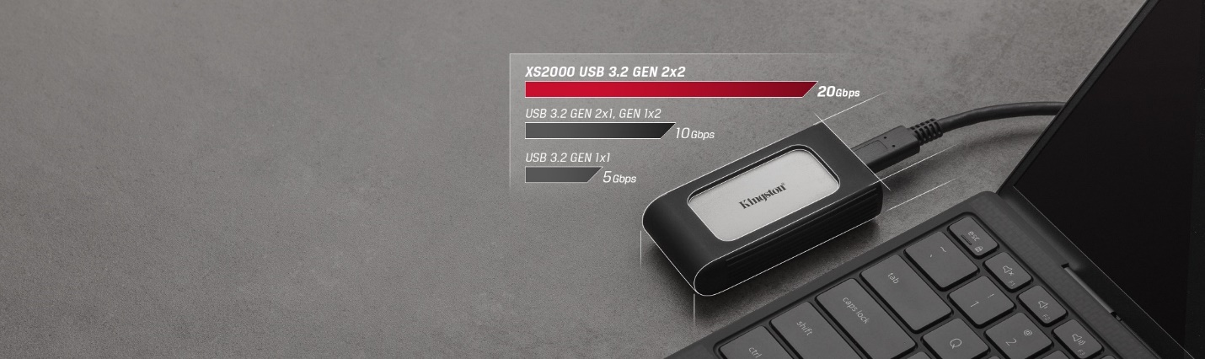

USB 3.2 Gen 2x2 Performance

Industry-leading read/write speeds up to 2,000MB/s1.



High-speed Capacities

Up to 4TB2 of space for a full library of your favorite photos, videos and the latest gaming titles.



Built for Durability

Tested to be water resistant, dust resistant and shockproof up to 6ft4 with an included rubber sleeve. Additional colors sold separately.5

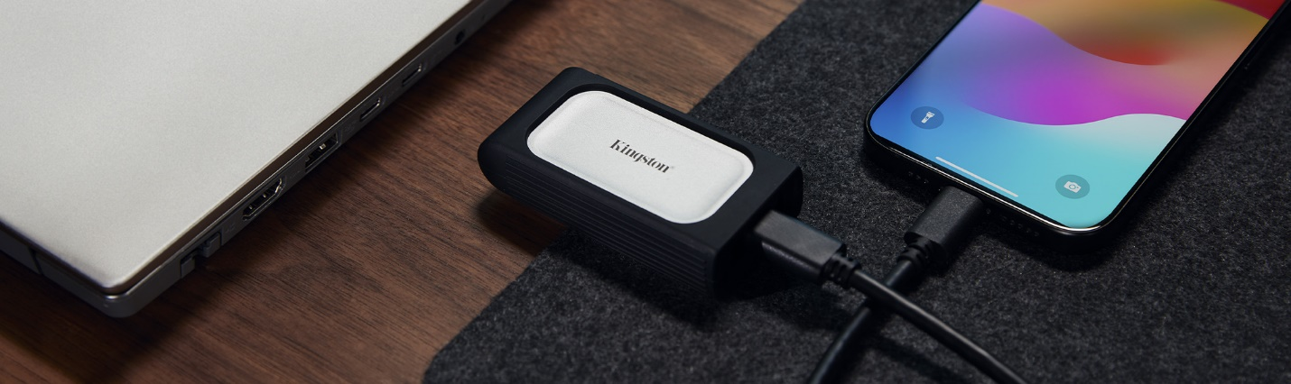

Compatible with the latest iOS and Android devices6

Free up storage on your smartphone with included USB-C to USB-C cable. [Learn more](https://www.kingston.com/blog/mobile-lifestyle/external-storage-iphone-15)



Works with PS5™

Expand the storage of your PlayStation and take your game collection on the go. [Learn more](https://www.kingston.com/blog/gaming/upgrade-ps5-internal-and-external-ssds)  
  
Works with PlayStation® 5

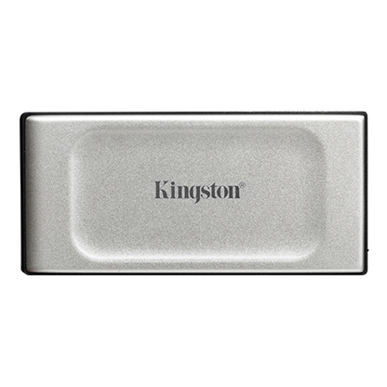

* [XS2000 Portable SSD High Performance External Drive](javascript:void(0))
* [XS2000 Portable SSD High Performance External Drive](javascript:void(0))
* [XS2000 Portable SSD High Performance External Drive](javascript:void(0))
* [XS2000 Portable SSD High Performance External Drive](javascript:void(0))

Capacity

 500GB

 1TB

 2TB

 4TB

* Part Number: SXS2000/500G
* Includes rubber sleeve and USB-C® cable
* USB 3.2 Gen 2x2
* Up to 2,000MB/s Read, 2,000MB/s Write

[**Where to Buy**](https://www.kingston.com/en/wheretobuy)

Accessories

* XS SSD Rubber Sleeve 3 Pack



* + Part Number: SNA-XSR1-3P
  + 3-pack multi-colored rubber sleeves
  + Package includes: black, light blue, orange
  + Fits XS1000, XS1000R and XS2000